Teams Attendance Export
Entra ID App Setup Guide
App-only (certificate) authentication • tenant-wide access policy
Prepared for: Rakso CT Education IT Version 1.0 Date: August 20, 2026

1. Overview
This guide sets up a Microsoft Entra ID app registration so the PowerShell tool Bulk-ExtractTeamsAttendance-Phased.ps1 can read Teams meeting attendance for your organizers automatically, without anyone signing in each time.
You will need: the Global Administrator role (for admin consent and the Teams access policy).
Time required: about 15 minutes of setup, plus up to 30 minutes for the Teams policy to take effect.
End result: an app with a certificate and three read-only Microsoft Graph permissions, authorized across the tenant to read online-meeting attendance.
Placeholders used below (replace with your values): <TENANT_ID>, <APP_ID>, <THUMBPRINT>, <your-domain>.

2. Prerequisites
- PowerShell 7+ installed on the machine that will run the script and hold the certificate.
- MicrosoftTeams module (for the access-policy step). Install with:
Install-Module MicrosoftTeams -Scope CurrentUser -Force
- Global Administrator rights in the tenant.
- Your Tenant ID (Entra admin center > Overview).

3. Part A — Create the certificate (PowerShell)
Run this on the same machine and user account that will run the extraction script. The private key stays in that machine's certificate store; you only upload the public .cer file.

Step A1 — Generate a self-signed certificate
$cert = New-SelfSignedCertificate -Subject "CN=RaksoTeamsAttendance" `
-CertStoreLocation "Cert:\CurrentUser\Mylocation(replace this with actual path)" `
-KeyExportPolicy Exportable -KeySpec Signature -NotAfter (Get-Date).AddYears(2)
$cert.Thumbprint # <-- copy this; you enter it when running the script
Export-Certificate -Cert $cert -FilePath "$HOME\RaksoTeamsAttendance.cer" | Out-Null
Copy the Thumbprint value and note where the .cer was saved (C:\Users\<you>\RaksoTeamsAttendance.cer).
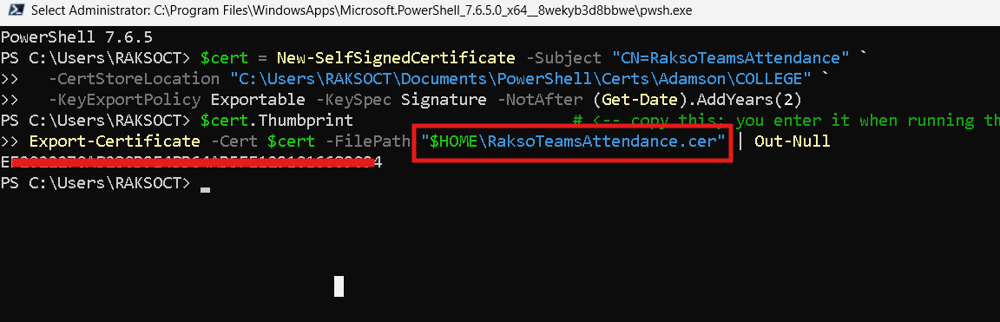

4. Part B — Register the application (Entra portal)

Step B1 — Open App registrations
Go to https://entra.microsoft.com > Identity > Applications > App registrations > New registration.
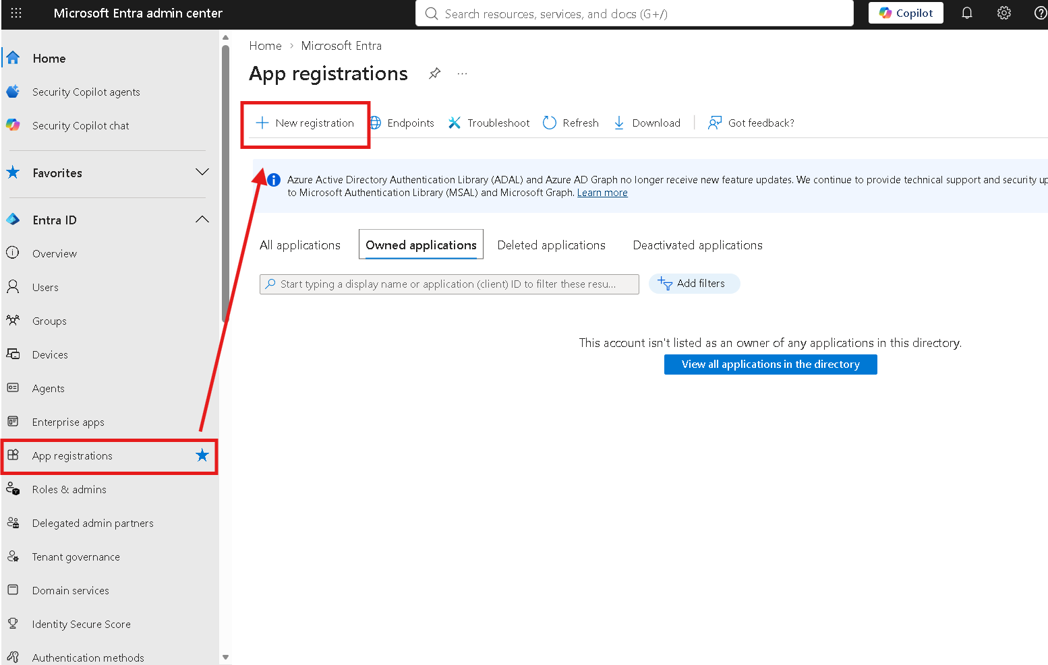

Step B2 — Fill in the registration
- Name: Rakso Teams Attendance Export
- Supported account types: Accounts in this organizational directory only (single tenant)
- Redirect URI: leave blank, then click Register
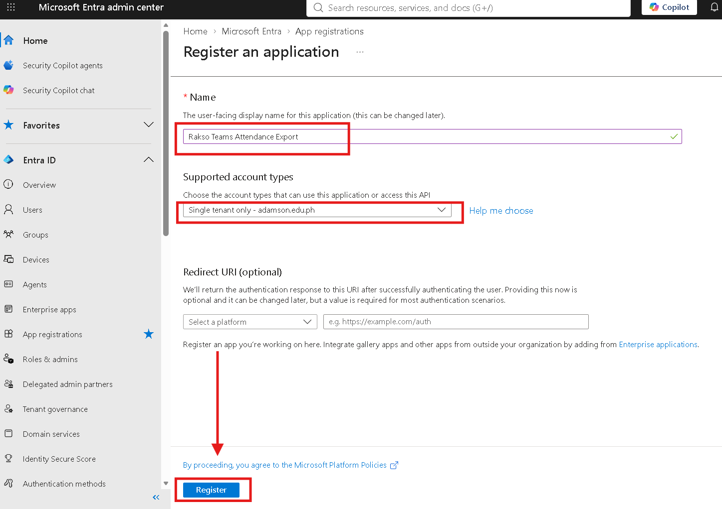

Step B3 — Copy the IDs
On the app's Overview page, copy the Application (client) ID and the Directory (tenant) ID. You'll need both.
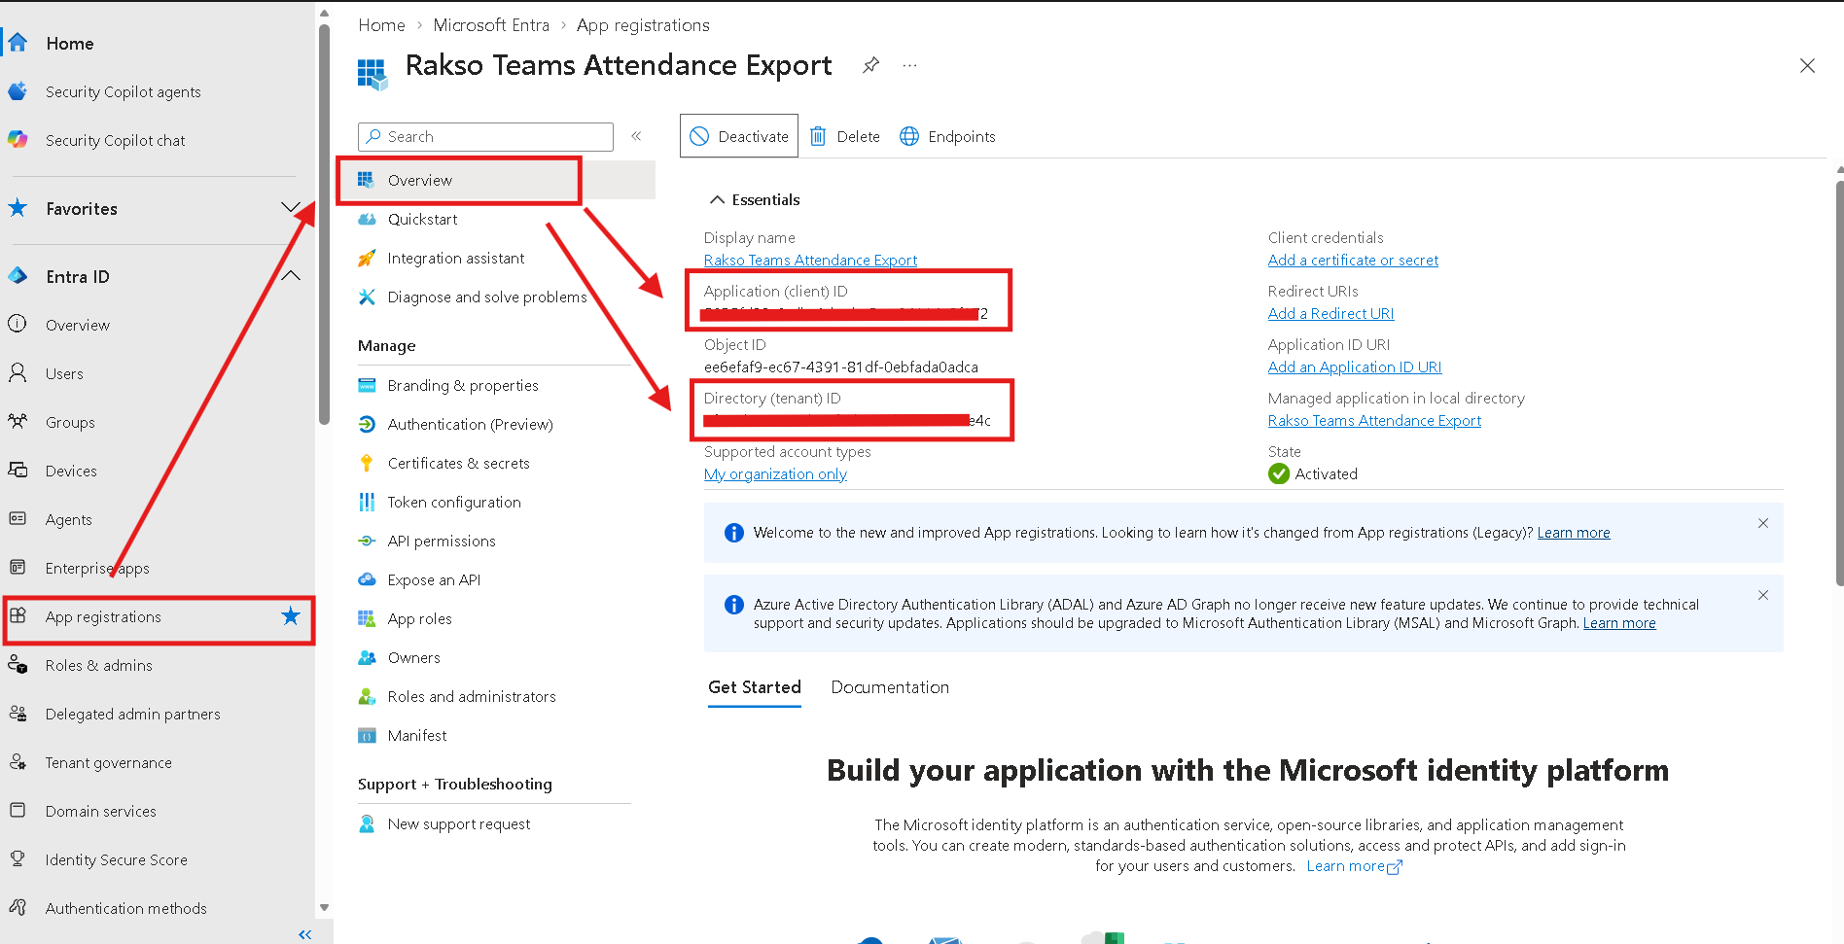

5. Part C — Upload the certificate

Step C1 — Certificates & secrets
In the app: Certificates & secrets > Certificates > Upload certificate. Select RaksoTeamsAttendance.cer and click Add. Confirm the thumbprint shown matches Step A1.
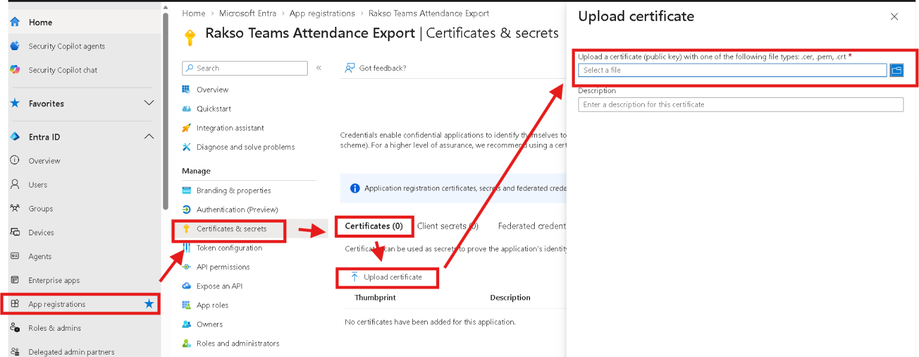

6. Part D — API permissions + admin consent

Step D1 — Add Microsoft Graph application permissions
In the app: API permissions > Add a permission > Microsoft Graph > Delegated permissions.
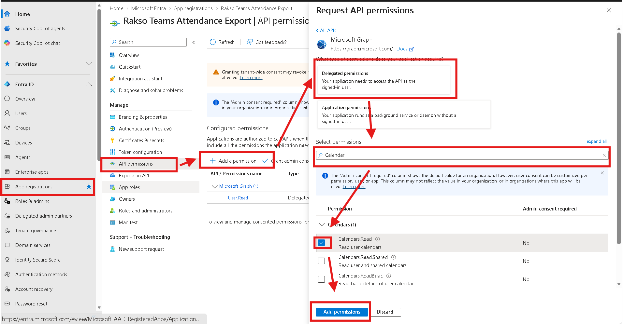

Step D2 — Select these three (read-only)
- Calendars.Read — find each organizer's Teams meetings
- OnlineMeetings.Read.All — resolve a meeting's join URL to the online meeting
- OnlineMeetingArtifact.Read.All — read the attendance reports and records
Optional: add User.ReadBasic.All only if your organizers CSV lists UPNs (email-style) rather than object IDs — it lets the script translate a UPN to the object ID the Teams API needs. You can skip it by putting each organizer's Object ID in the CSV instead.
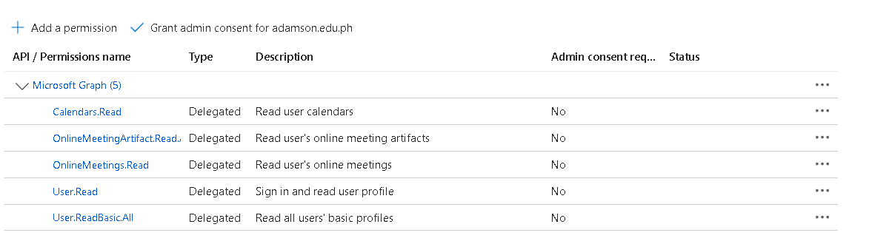

Step D3 — Grant admin consent
Click Grant admin consent for <your-domain> > Yes. Confirm every row shows a green Granted status.
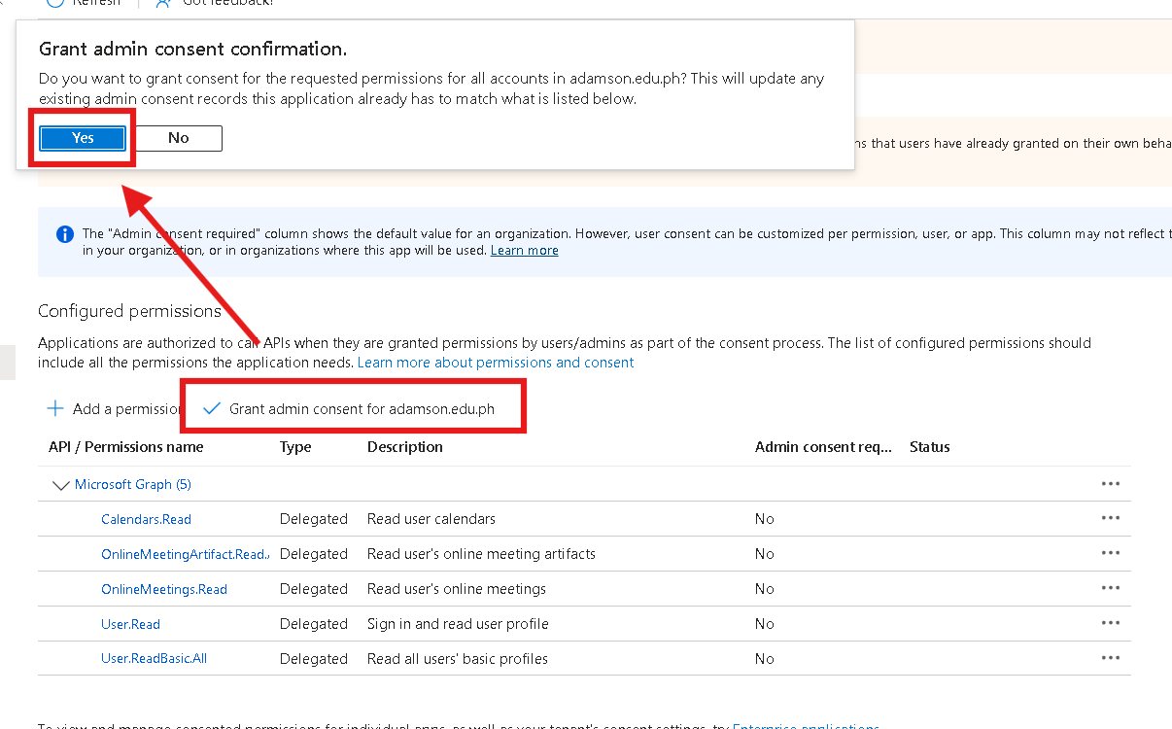

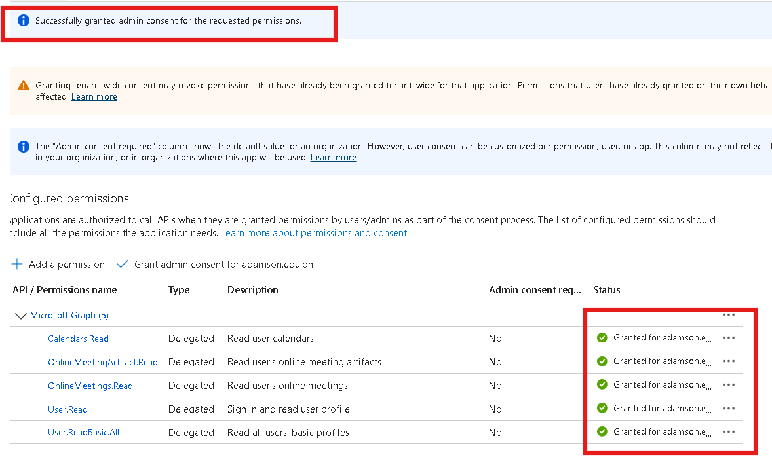

7. Part E — Authorize the app for online meetings (Teams)
App-only calls to a user's online meetings are blocked (HTTP 403) unless a Teams application access policy authorizes the app. This step grants it tenant-wide.

Step E1 — Connect to Microsoft Teams PowerShell
Connect-MicrosoftTeams # sign in as an administrator
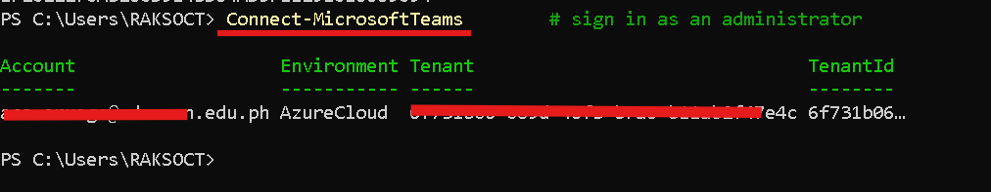

Step E2 — Create and grant the policy (tenant-wide)
New-CsApplicationAccessPolicy -Identity "RaksoTeamsAttendance" `
-AppIds "<APP_ID>" -Description "Attendance export"
Grant-CsApplicationAccessPolicy -PolicyName "RaksoTeamsAttendance" -Global
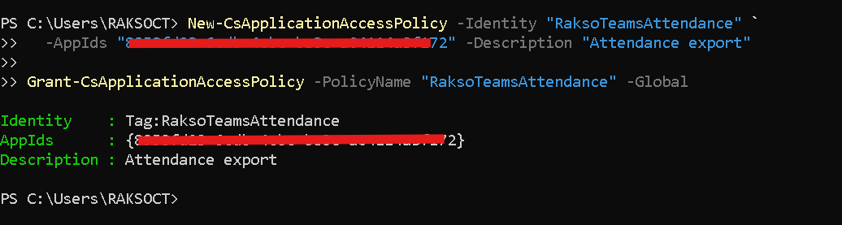
Important
Wait up to 30 minutes for the policy to take effect before running the script.
-Global applies to every user in the tenant. For least privilege, scope it to a security group instead (see Section 9).

8. Part F — Verify and run

Step F1 — Confirm app-only sign-in works
Connect-MgGraph -TenantId <TENANT_ID> -ClientId <APP_ID> -CertificateThumbprint <THUMBPRINT> -NoWelcome
(Get-MgContext).AuthType # should say: AppOnly
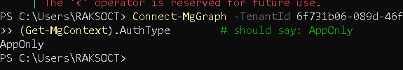

Step F2 — Run the extraction script
Run Bulk-ExtractTeamsAttendance-Phased.ps1. At Phase 2, choose [2] App-only (certificate) and enter your Tenant ID, Application (client) ID, and the certificate thumbprint from Step A1.
🖼 Screenshot placeholder
Script Phase 2 — auth mode [2] selected, prompting for App ID and thumbprint
(paste your screenshot here — delete this box)

9. Troubleshooting & recommendations
Symptom | Cause / Fix
403 Forbidden on meetings / attendance | Teams access policy not granted or not yet propagated (wait up to 30 min). Re-check Part E.
Calendar reads OK but attendance is 403 | OnlineMeetingArtifact.Read.All not added or admin consent not granted (Part D).
"Certificate ... not found" at connect | Wrong thumbprint, or the certificate is not in the runner account's Cert:\CurrentUser\My store.
"userId ... is not a valid GUID" | Put each organizer's Object ID in the CSV, or add User.ReadBasic.All so UPNs can be translated.
Dates outside your range appear | Expected for recurring meetings; the script filters reports to your date window (v1.3.0+).

Security recommendations (insights)
Certificate over secret: nothing secret travels in requests and there is no secret string to leak; rotate the cert before its NotAfter date.
Least privilege: tenant-wide (-Global) is simplest but lets the app read ALL users' online-meeting attendance and calendars. To limit it, create a security group of just the organizers and grant Teams with -Group <group>, plus scope calendars in Exchange: New-ApplicationAccessPolicy -AppId <APP_ID> -PolicyScopeGroupId <group> -AccessRight RestrictAccess.
The output contains student names, emails, and attendance (personal data) - store the CSV/report files in a restricted location and apply a retention limit.
Record the app's owner and review its sign-ins periodically; the three permissions are read-only, so the app can never modify tenant data.

